*Part PS2b*.

Based on the ps2a, I wrote a PhotoMagic.cpp for encode and decode image. Using PNG image for encode because it is 8-bits so it can be encode. The program using the same LFSR files from ps2a but I add more function to get picture encode. I note that the generate function from LFSR will determine the running time for encoding. The bigger bit shift, the slower the encode time run. So I set it to 9 is just enough to encode in a short.

*For extra credit:*

I note that every single character from a string is 6 bits string. So I take every single character from alphanumeric password and compare to the base64 if it is in there or not. If yes then I take that character and using bitset library to convert it to 6 bits binary then I join them together to get the final binary bits string for encode.

After this assignment, I had known more about bit shift in digital which I have learned from the Logic Design class and how to apply the bit-shift to daily life. This can be use full if I want to share encoded pictures to my friend on the internet and only people who know the key can decode the pictures

Encode output:

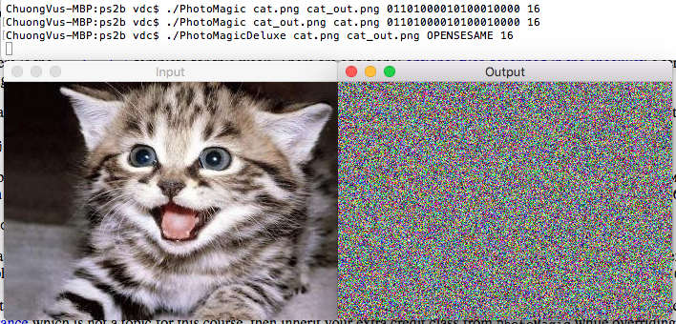

Decode Output:

